

SAVEETHA SCHOOL OF ENGINEERING
CAPSTONE PROJECT
IP Configuration for a Gram Panchayat Office Network

NAME: ABHISHEK P

REGISTER NUMBER: 192325107

COURSE CODE: CSA0747

COURSE NAME: Computer Network for IOT
INTRODUCTION:

Establishing a reliable and efficient network infrastructure for a gram panchayat office is essential for enabling smooth administrative operations, effective communication, and access to essential government services. The network must support a diverse range of functions, from managing day-to-day tasks to facilitating interactions with higher administrative bodies and citizens. This entails a thorough assessment of the office's specific needs, including the number of users, the types of devices in use, and the applications required for efficient operation. Additionally, evaluating the existing infrastructure, such as internet connectivity, network cables, and power sources, is crucial to determine the most suitable connectivity options.

Objective:
- Assess User and Device Requirements: Determine the number of users and types of devices (computers, printers, phones, etc.) to ensure the network supports all necessary functions and applications efficiently.
- Evaluate Existing Infrastructure: Analyze the current state of internet connectivity, network cables, and power sources to identify any gaps and leverage existing resources effectively.
- Determine Connectivity Options: Choose the most suitable connectivity options (wired, wireless, or a combination) based on factors such as proximity to network access points, terrain, and budget constraints.
- Design a Scalable Network Architecture: Develop a network layout that supports the office’s administrative tasks, ensures high performance, and allows for future growth and expansion.
- Implement Robust Security Measures: Protect the network and sensitive data from cyber threats and unauthorized access by incorporating appropriate security protocols and tools.
- Deploy Network Monitoring Tools: Establish monitoring systems to continuously track network performance, detect anomalies, and facilitate real-time troubleshooting to maintain optimal operation.
- Ensure Cost-Effectiveness: Balance performance and security needs with budget constraints to provide a cost-effective solution that delivers value while staying within financial limits.

LITERATURE REVIEW

The approach to designing a network for a gram panchayat office is well-structured and addresses key aspects of network planning, including user requirements, existing infrastructure, connectivity options, scalability, security, and cost-effectiveness. Ensuring a comprehensive assessment and planning phase, while incorporating provisions for future growth and evolving technology, will contribute to a robust and efficient network infrastructure.

METHODOLOGY

Software:

- Cisco Packet Tracer

Network Design:

Network consist of
- 4 router
- 4 printer
- 4 phone
- 4 PC
- 1 server

IP Address Allocation:

- Router and Switches: Configure static IP addresses for critical network infrastructure devices (e.g., router interfaces, core switches) to ensure stable communication.
- Servers and Printers: Assign static IP addresses to servers and network printers to ensure they have consistent network addresses.
- Configure Devices
- On Computers and Other End Devices:
- Automatic IP Configuration (DHCP):
  - Configure Network Settings: Set devices to obtain an IP address automatically from the DHCP server.
- Manual IP Configuration (Static):
  - Assign IP Addresses: Input static IP addresses, subnet mask, gateway, and DNS servers if not using DHCP.

Protocol: -
1. Routing Protocols
- OSPF: For routing within a company’s network.
- BGP: For routing between different companies.

2. Network Management
- SNMP: For monitoring and managing network devices.

3. Data Link Layer
- Ethernet (IEEE 802.3): For local area network connections.
- PPP: For serial communication between routers.

4. Addressing
- IPv4: For IP addressing and routing.

5. Configuration
- DHCP: For automatic IP address assignment.
- ARP: For mapping IP addresses to MAC addresses.

6. Security
- IPsec: For encrypting and securing IP communications.
- VPN: For secure remote access and inter-company communication.

RESULT:
Network Design:
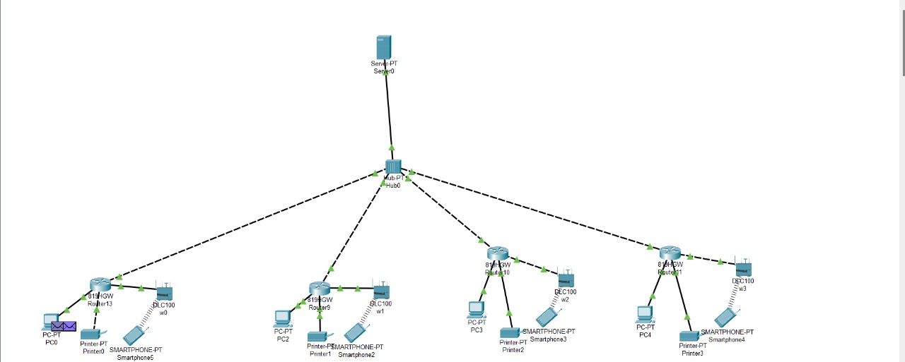
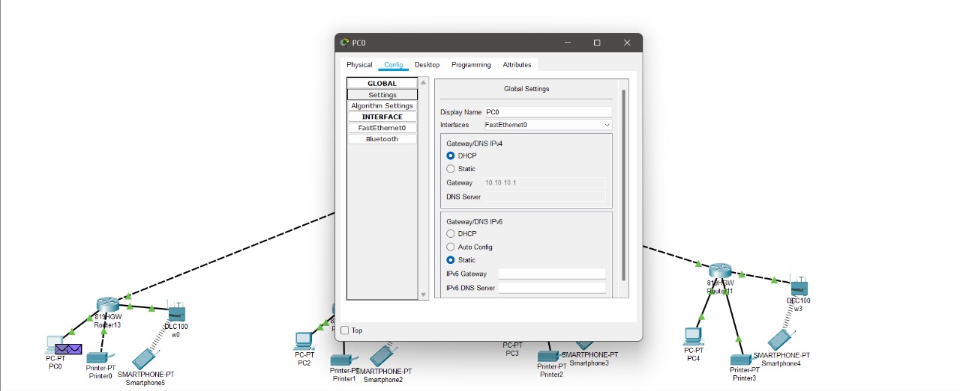

CONCLUSION:

In conclusion, configuring IP addresses for a gram panchayat office is a fundamental task that lays the groundwork for a reliable and efficient network infrastructure. By carefully planning and implementing an IP addressing scheme, you ensure that all network devices, including computers,
printers, and network equipment, can communicate seamlessly. This involves selecting appropriate IP address ranges, configuring both static and dynamic IP assignments, and ensuring robust network security.
The process includes setting up DHCP for dynamic IP allocation, assigning static IP addresses to critical devices, and verifying the configuration through connectivity tests. Implementing security measures, such as firewalls and network segmentation, helps protect the network from unauthorized access and potential threats.

